**Notes from David on his sampling biases, 03-09-22**

**Image based groundtruthing of DW classification typology for ecosystem extent accounting**

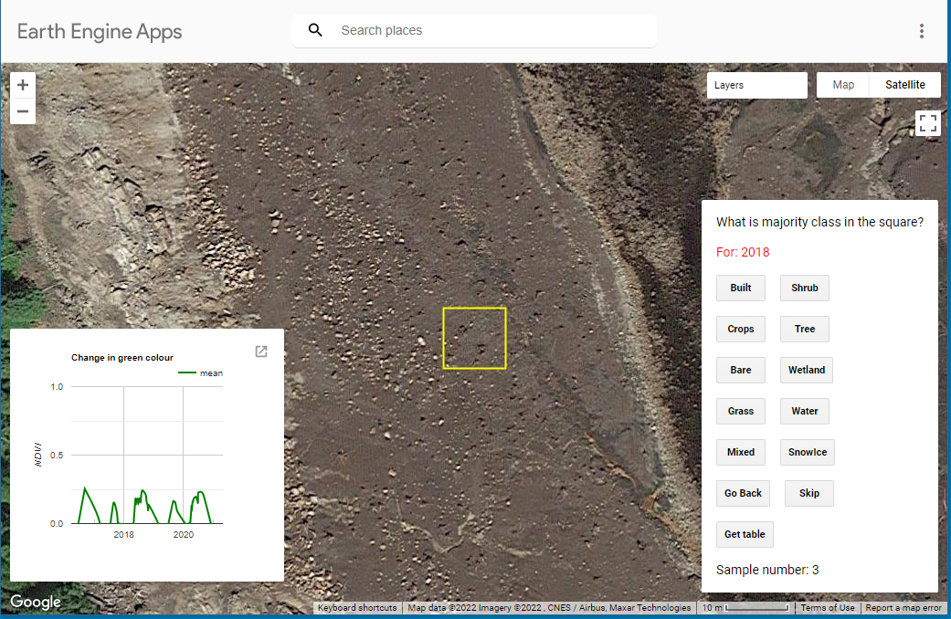

Difficulty in using the **ecosystem typology instructions:**

* Regulated lake / river - bare ground in image, but this indicates a seasonal condition
* 0-Water is not present in the image., but drainage line information and bare ground around the pixel informs interpretation
* =Land that can or has previously been covered by water
* Seasonally flooded, but does not contain vegetation in the image, but the NDVI says there is some vegetation. In this case the NDVI+the landscape context is external information that may bias towards the DW type “flooded vegetation”, but it is bare ground.
* Flooding may be observed in another image, but here it is not water. Unclear DW classification instructions.

**App interface:**

* “Wetland” button is not described in the typology. So classifier may bring external definition criteria not in the Dynamic World taxonomy. The Norwegian definition is narrower than the Ramsar definition <https://artsdatabanken.no/Pages/318299/Wetlands>. This ambiguity between the app label and the typology may be called out by non-Norwegian reviewers?

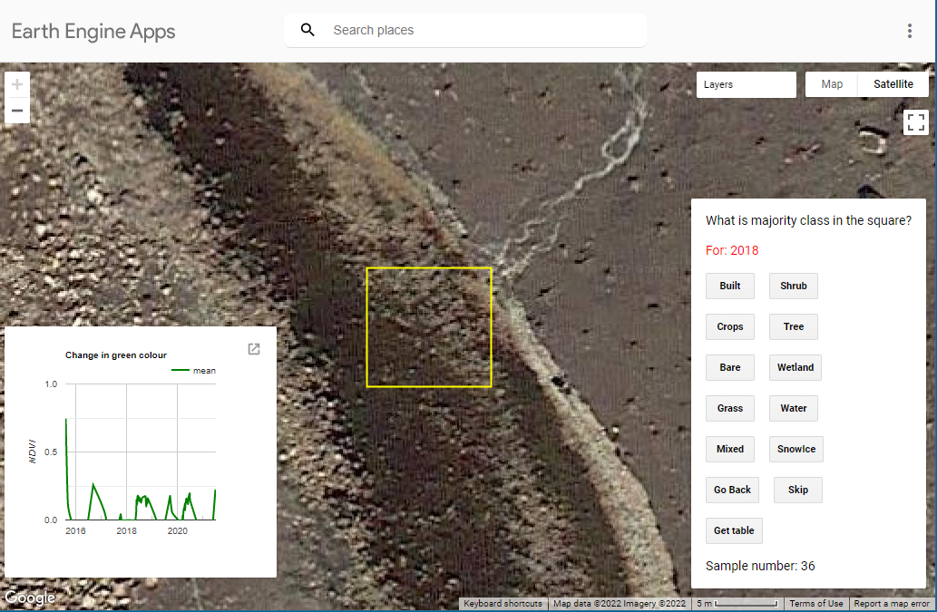

**Framing bias**: If I select “water” I am classifying for land cover / extent. If I select “bare ground” I am classifying with a drought ecological condition purpose in mind. If I classify as “flooded vegetation” I am following the DW typology to the letter. The classifiers purpose framing may be a bias here as well.

**Resolution bias**: This image there is 50 water 50 bare ground at close zoom, but water if I reduce resolution.

**Information loss:** A “mixed” classification here is very different from a “mixed” tree-built. The “mixed” typology is potentially losing a lot of information that the human observer can provide.

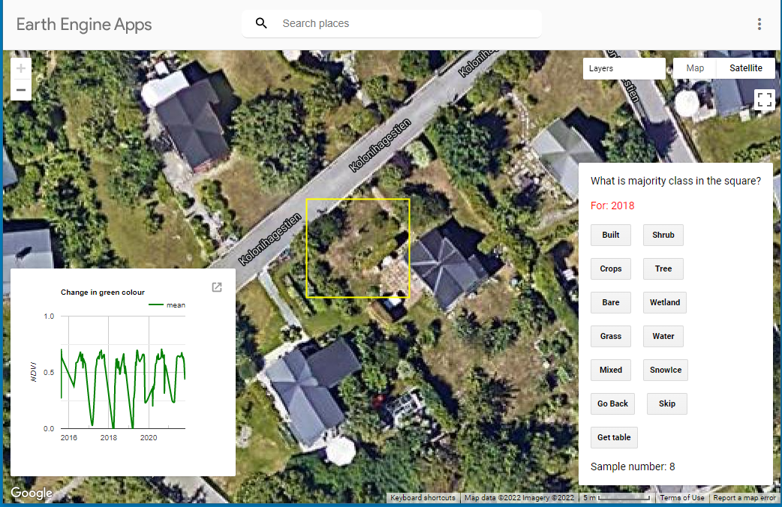

**“Classification purpose bias**”: Majority cover is grass; but from landscape form it is mixed. If classified as mixed it would be because of using context information outside the sampling frame about this being vegetation in an suburban environment. If the classifier has a purpose in their mind for the classification this may determine their choice – for example from a hydrological perspective this grid cell has run-off properties closest to a cell covered in grass. Should classifiers be asked to be conscious of such “purpose biases”. Perhaps some purpose definition can reduce classification noise between classifiers.

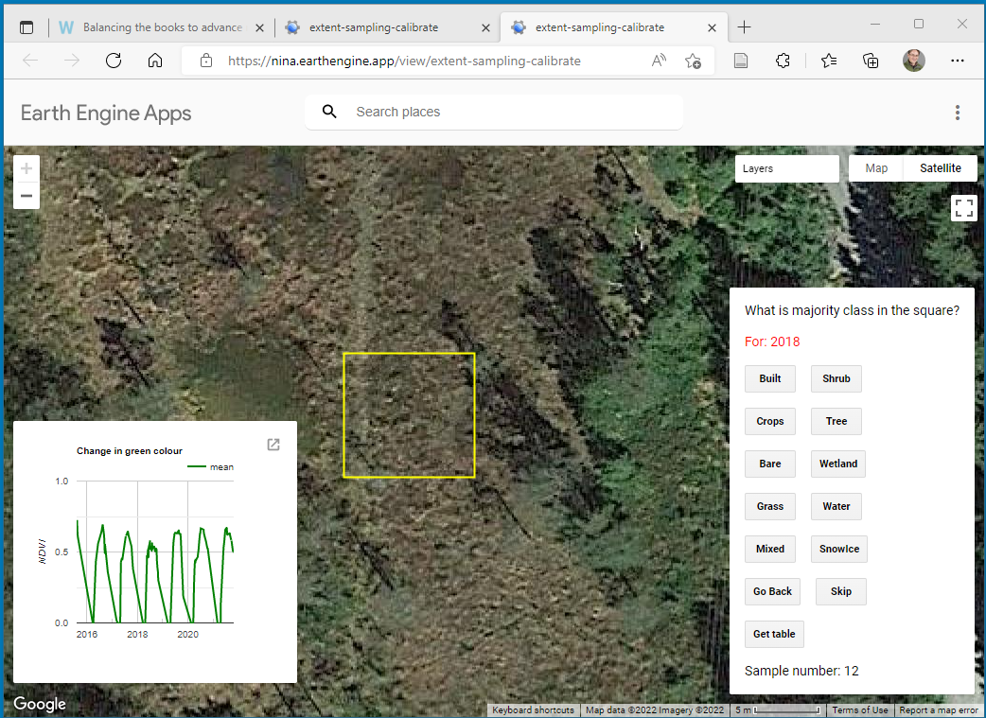

**Context bias**: The use of information outside the sampling frame may be used to infer “obvious intermixing with water” which cannot be observed in the frame itself . Water to the east here and lack of trees while present in a “pond shaped” surrounding indicating a high water table. The NDVI does not show any periods of no chlorophyl or open water, but it is likely below the vegetation because of the adjacent apparent water surface and lack of trees.

3-Flooded vegetation in **DW has contradictory classification instructions**:

• Do not assume an area is flooded if flooding is observed in another image.  
• Seasonally flooded areas that are a mix of grass/shrub/trees/bare ground

DWs “flooded vegetation” class does not have the same definition as <https://artsdatabanken.no/Pages/318299/Wetlands>. Again here classifiers may be mobilizing external knowledge from a Norwegian definition to mark “wetland” when DW instructions are ambiguous.

I marked “wetland” admitting use of external knowledge – in my case non expert as I am not an ecologist.

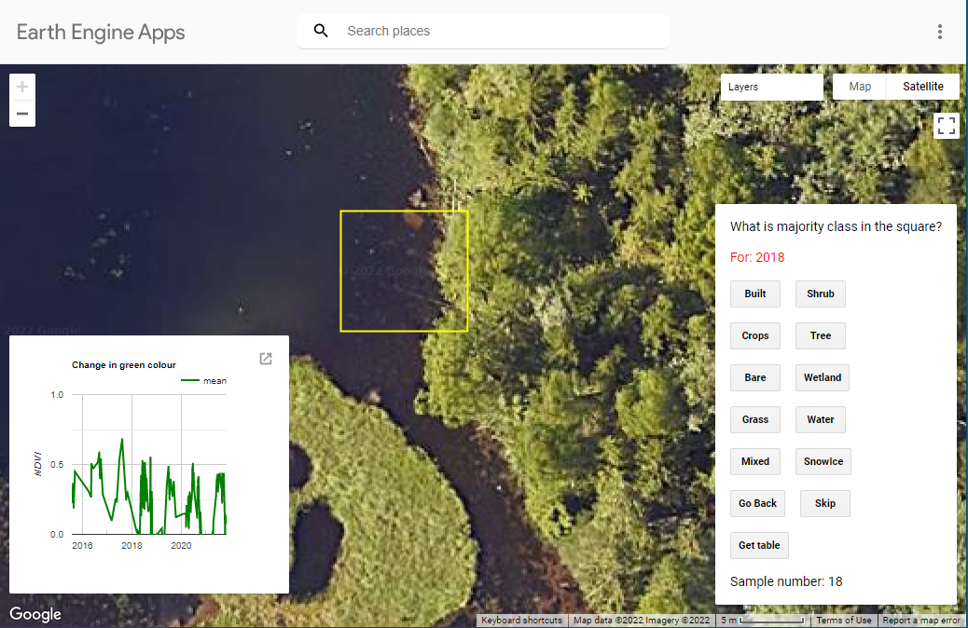

Seasonality I initially classified this as “water” if moving fast and consciously ignoring the context of the frame. At some other part of the year this frame may be bare ground and/or water as indicated by the NDVI graph.

Based on combination of surroundings+NDVI change I would classify as DW “flooded vegetation”, but this cannot be seen from the image, and it is not “wetland” as defined by [Wetlands (artsdatabanken.no)](https://artsdatabanken.no/Pages/318299/Wetlands). Tree canopy over water may make the NDVI trace look like flooded vegetation.

In the DW typology a tree whose base is periodically flooded would enter into “flooded vegetation” and have this NDVI, but may not be “wetland” as defined by [Wetlands (artsdatabanken.no)](https://artsdatabanken.no/Pages/318299/Wetlands).

The human eye detects some depth and a rocky bottom, finally helping me make the determination for “water”. I think the NDVI trace is due to the partial canopy in the image.

This is another example of potential bias with the lacking correspondence between the **“wetland” button and the sparse and internally inconsistent DW definition** – a high water table as well as a low water table will underrepresent some.

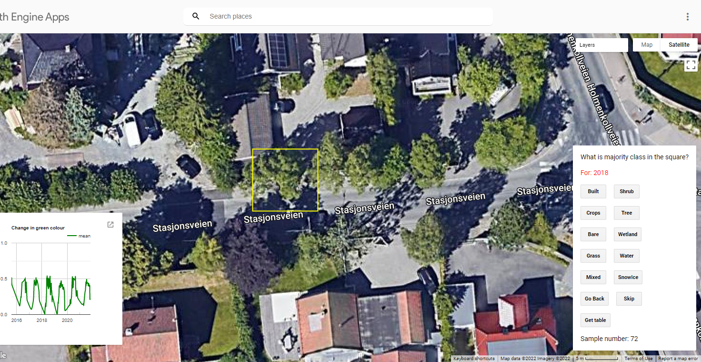

Classified as tree. But note as a deciduous & street tree the NDVI goes down to zero at times, which is different from a tree in an unbuilt environment Could be good to **include a “ single/street tree” example in the tutorial.**

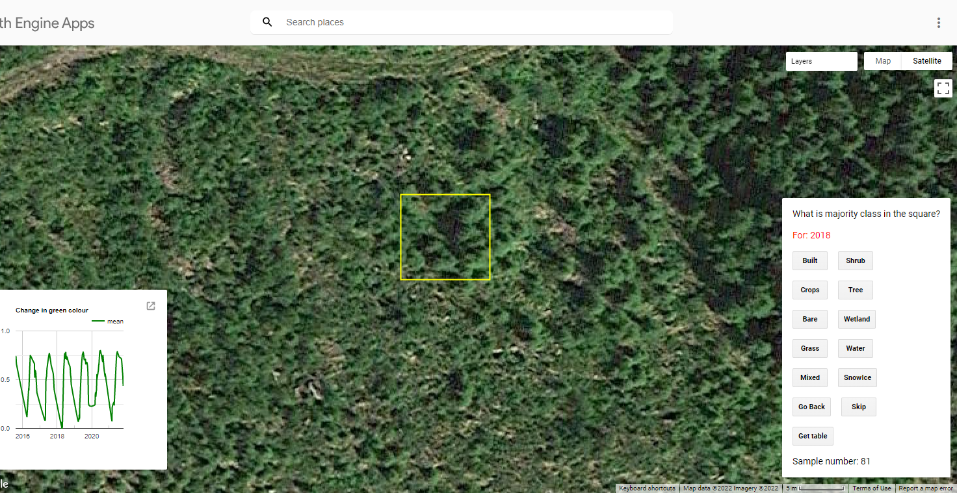

**Context bias again**: Classified as trees based on pixel alone, but it could have gone shrub if I had let myself be biased by the neighbouring cells.

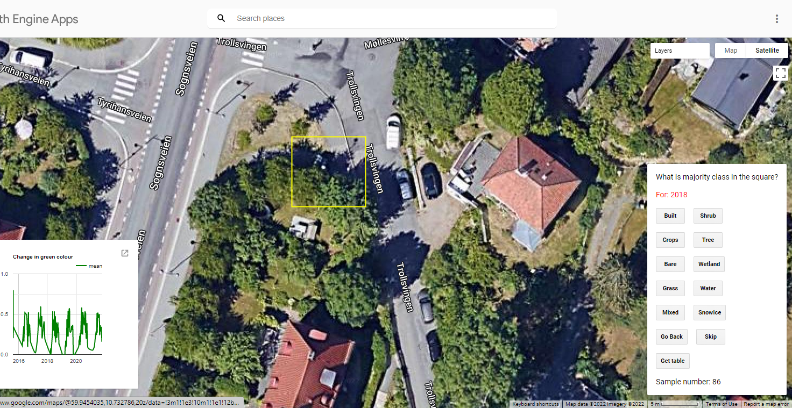

**“Partitioning bias”.** First reaction “mixed” because apparent 50-tree 50-built. But zoom in to canopy shade and I identify grass which tips the largest single landcover share to tree-50, grass-20, built-30. In this case the mathematical instruction for the “Mixed class” leads to a large overestimate of tree canopy cover.

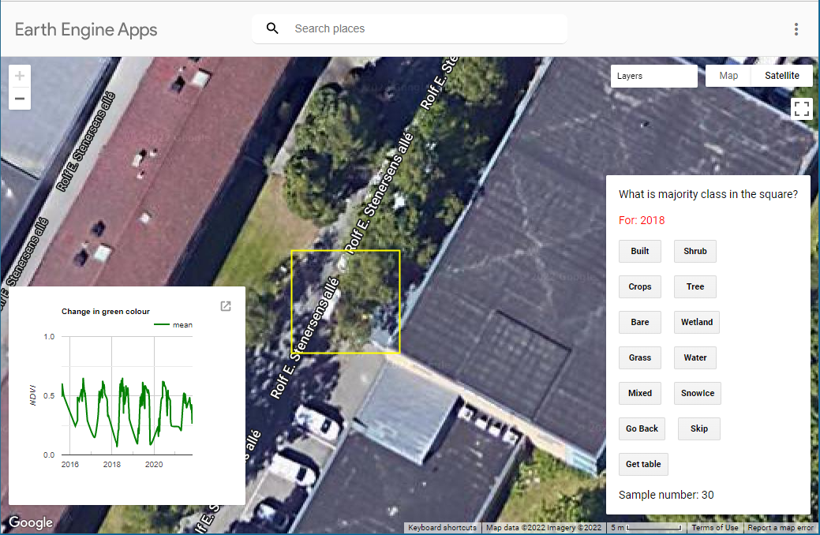

I would choose “mixed” for this frame based on 50 tree-50 built. But the “mixed” classification does not indicate what the vegetation component of mixed is. This is a loss of information relative to the purpose of urban ecosystem classification. The classifier would be capable of distinguishing a sub-class of “Built-Tree”, “Built-Grass”, “Built-Shrub” which would make a big difference for ecosystem service modeling.

A further bias in this image could be a classification of “Built” as the classified knows that while the canopy covers 50% at ground level the frame is mainly built.

Street trees may also underidentified also because of DWs definition of “any significant clustering of dense vegetation”…this does not cover solitary trees,

Since an important use of the data for our synthesis projects is urban ecosystem accounting, a **debriefing on particular classification biases** in urban built zones would be useful. Did classifiers who have worked with urban systems represent more urban trees than in DW or other NINA colleagues, because they have a given data application in mind? E.g. this paper calls for classification of urban vegetation with the purpose of ecosystem service modeling in mind: <https://www.sciencedirect.com/science/article/pii/S1618866722001790>

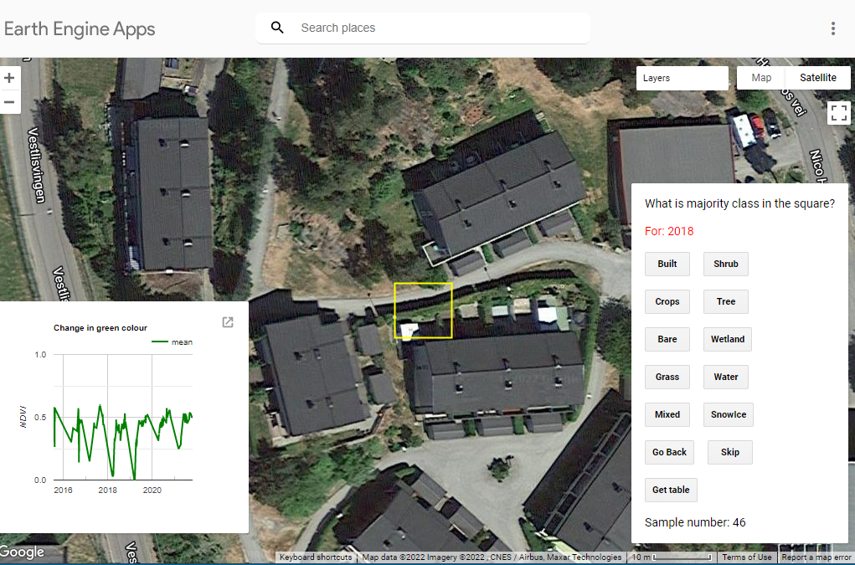

Classified this as mixed. Again information loss on easily identifiable BG structures in the built environment.

I note that it is feasible to identify “hedge rows” as distinct from grass very easily. Probably green roofs as well.

How many hours would it take you to set up this app to **generate dedicated training data for** **BGF typology** classification specifically for RS classification of built zones? How many data points/hours training would we need to budget for greater Oslo built zones only?

This paper argues that there is a lack of reference data for “private green” in urban RS classification work <https://www.mdpi.com/2072-4292/14/4/1031/htm>

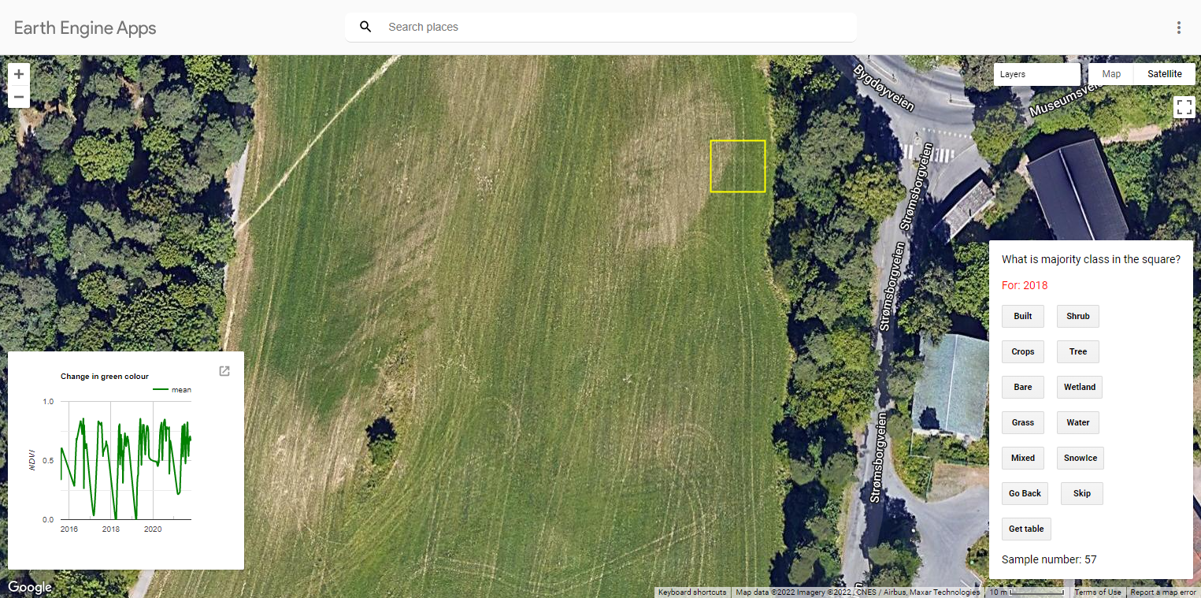

Possible confounding of “grass” and “crop” category. On many farms in the peri-urban area farmers plant grass as feed for e.g. horses. Emphasise the “human plotting” aspect. The instruction slide with “mowed grass example” may be confounding with harvested grass with a tractor.

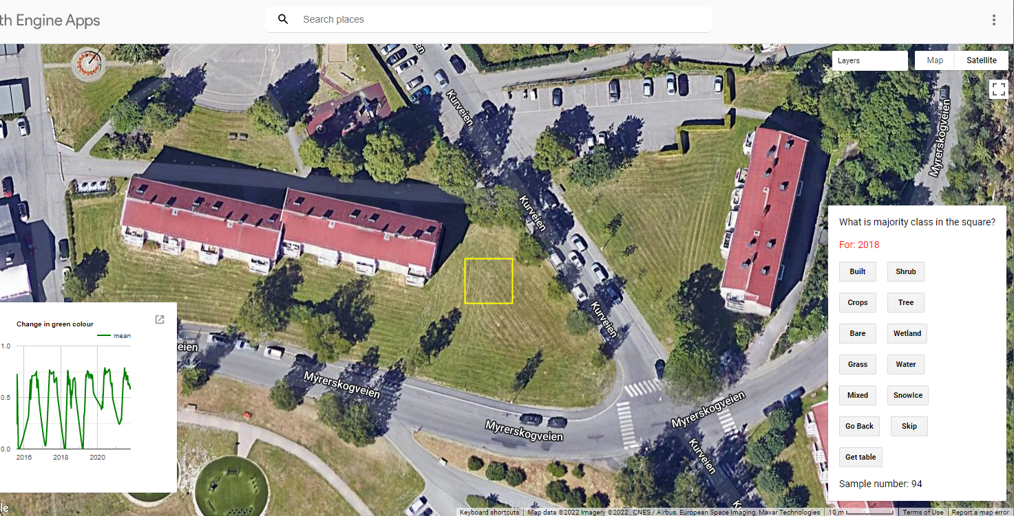

**Systematic Context bias across ecosystem types**: In this case the context tells us it is grass which is not crop, although the “mowing lines” would be interpreted similarly between this and the previous image if you couldn’t see the landscape.

I imagine you can do an analysis of systematic bias by regressing on a landuse classification for a window that encompasses the samping point and/or ask classifiers to pick a landuse type from a drop down as an additional info on context.

Hypothesis: That could be an interesting feature to include in the continuation of the groundtruthing – and then use it to write a dedicated paper on “classification uncertainty of landcover across ecosystem types in ecosystem accounting”. The hypothesis is that spectrally and even structurally identical images of the plots will be classified differently because the classifier uses landuse/ecosystem function knowledge from outside the frame, and outside the classification typology, to make a classification decision.

A quick Google of “remote sensing image ecosystem classification groundtruthing bias” shows that studies quantifying bias are focused on a particular ecosystem type. I did not see any papers evaluating whether there is a systematic classification bias across ecosystem types due to “expert context knowledge” being used by classifiers in addition to what is provided by the classification protocol.

**Summing up**

I just finished 100 calibration points as well. I noted down my own classification problems, decisions and self-evaluation of biases in a file I put in P:\15220700_gis_samordning_2022_(marea_spare_ecogaps)\David - I must admit that I did not read Ander's questions and Zander's clarifications above before I did the exercise. I had a number of similar questions - but perhaps it is useful to have a separate evaluation of the typology and tutorial material - I guess it will eventually become appendices to a paper and so useful to put some work into revising it before continuing? Aside from small details, I am amazed at the clarity of the classification instructions and the ease of using the app. I noted that in downloading my csv. files they both has the same name, which might be a source of confounding when copy pasting them over from the download to our folders on P. From the tutorial I thought the downloads would save directly to the folders.

I wondered for the purposes of a paper on validation/uncertainty whether we state that we the classifiers were "expert" or not. This seems to me double edged sword – an expert brings implicit contextual and unididentied knowledge to the classification exercise. One mark of groundtruthing robustness could be that “non topic experts” are able to implement a protocol in the same way, without using contextual information. But on the other hand, the examples above illustrate to myself that contextual knowledge, whether (i) visual from around the sampling point , (ii) from ecological knowledge supported by NDVI dynamics, or (iii) layperson landscape knowledge, can potentially increase accuracy, reduce unclassified cases. But I wondered whether we could do some more work on identifying systematic expert knowledge biases.

I would not be able to make these reflections without the methodology being so clear. Thanks so much for the huge effort, and for letting me try this with you!